Add cover Add comment

**How To Use lntermarket Analysis**

All 4 groups move closely related

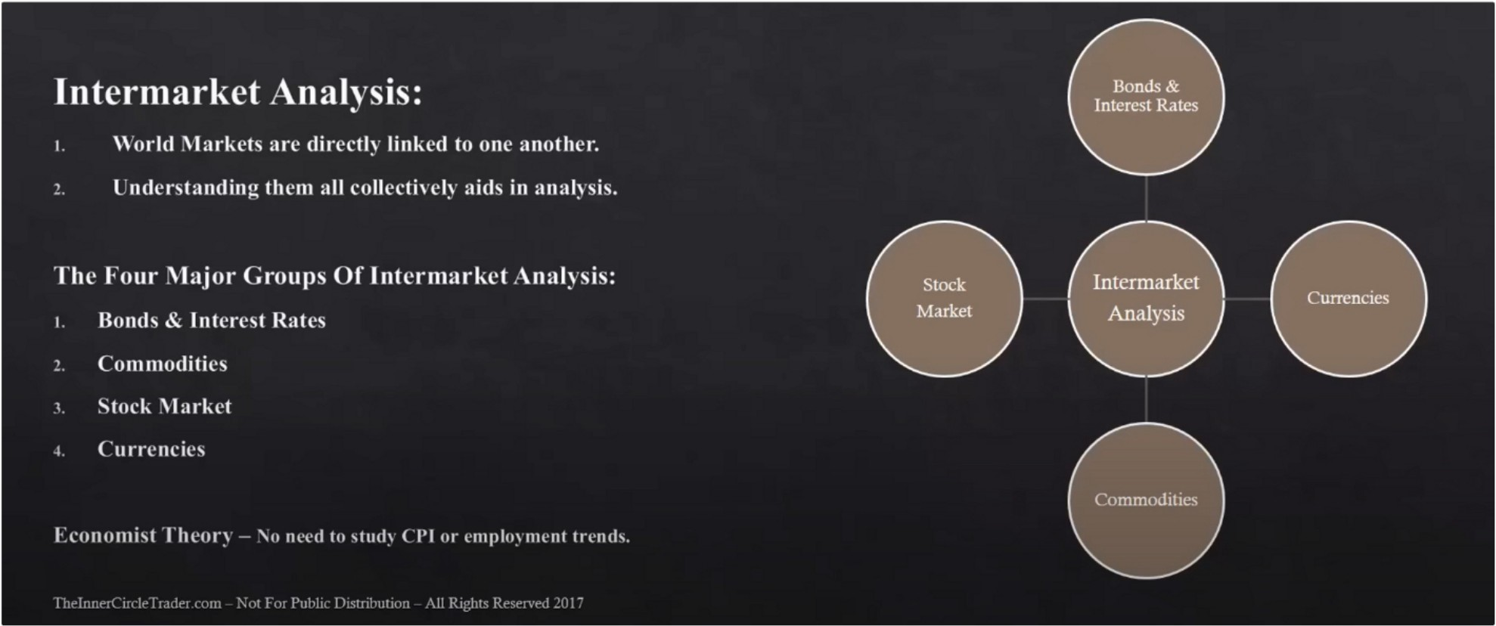

Bond and stocks generally move together, the bond not the yield. The treasury bond market. If the bond market rallies, generally thats supportive for a bull market for stocks. And when the bond market drops its going to be hard for stocks to rally, doesnt mean it cant rally, it just means that that underlying trend of the bond market moving lower is going to have an effect adn wait on that stock market rally and eventually youre going to have to pay the piper and that stock market is going to have to correct and get back in alignment with the trend of the bond market.

If youre going to be a stock trader, you want to look at the bond market as an indicator to see that you have underlying strength in the bond market. If the bond market is going higher and youre a buyer of stocks, then you have the fundamentals that back you up and its high probability.

If bond prices drop then interest rates are rising and stock market and bond markets doesnt like when interest rates are rising so they will drop

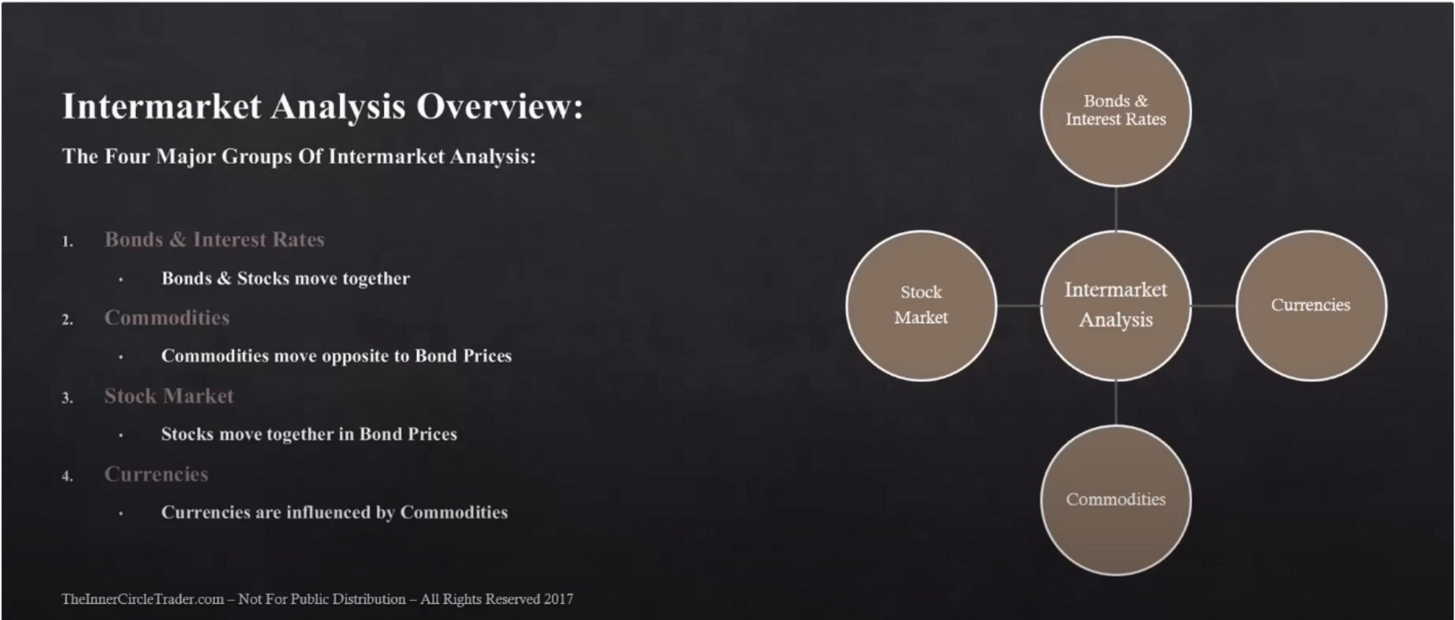

The effect of export sales of commodities and production is going to have an effect on some currencies

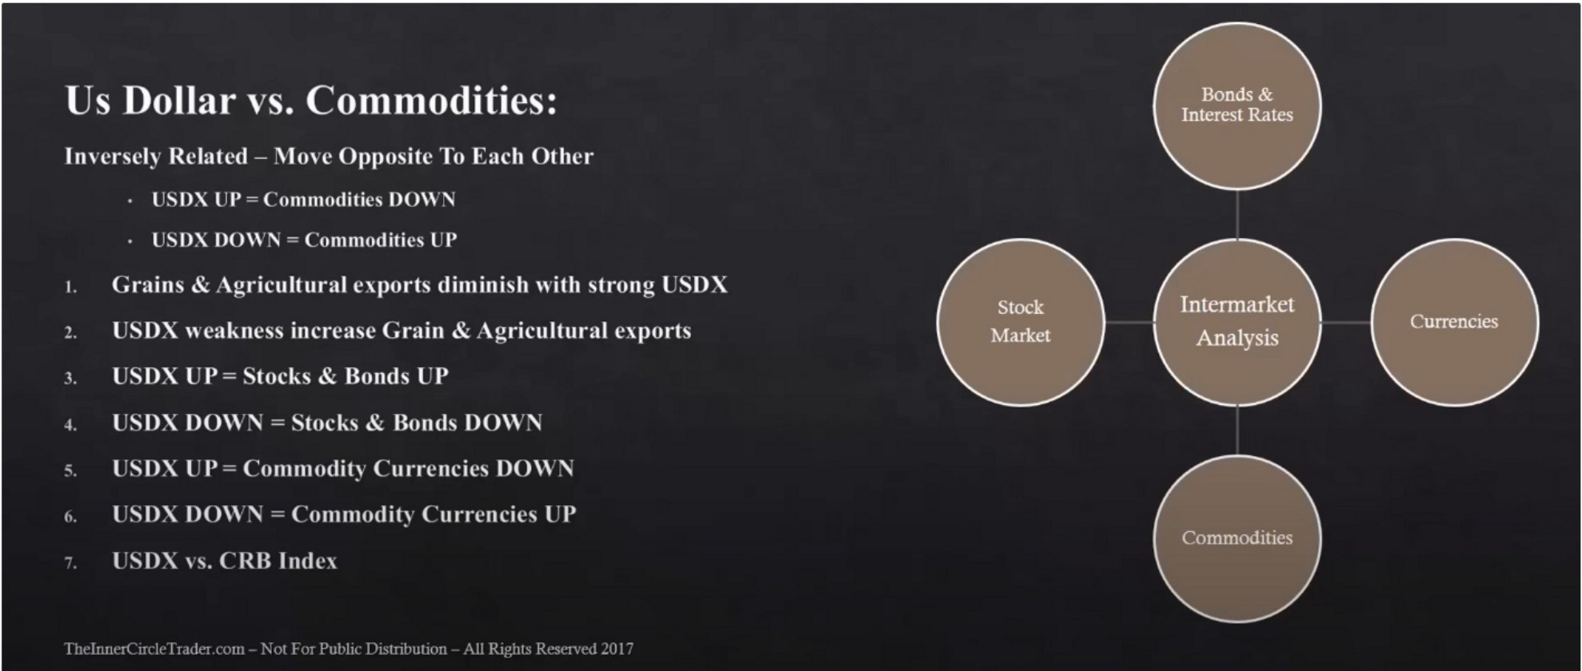

CRBtrader.com

If we want to see signs of inflation, its going to be noticed in commodities

Bonds can rally up and commodities can go down later on, like 6/12 month lag time. It doesnt give you an immediate feedback. It takes a long time sometimes

CRB is very heavy on agriculture on green market prices, like soybean prices, wheat, corn, cattle, hog prices

Use goldman sachs commodity for energy sided prices

When goldman sachs industrial metal index rises thats a good global trend indicator, remember that its industrial metal so not gold and silver

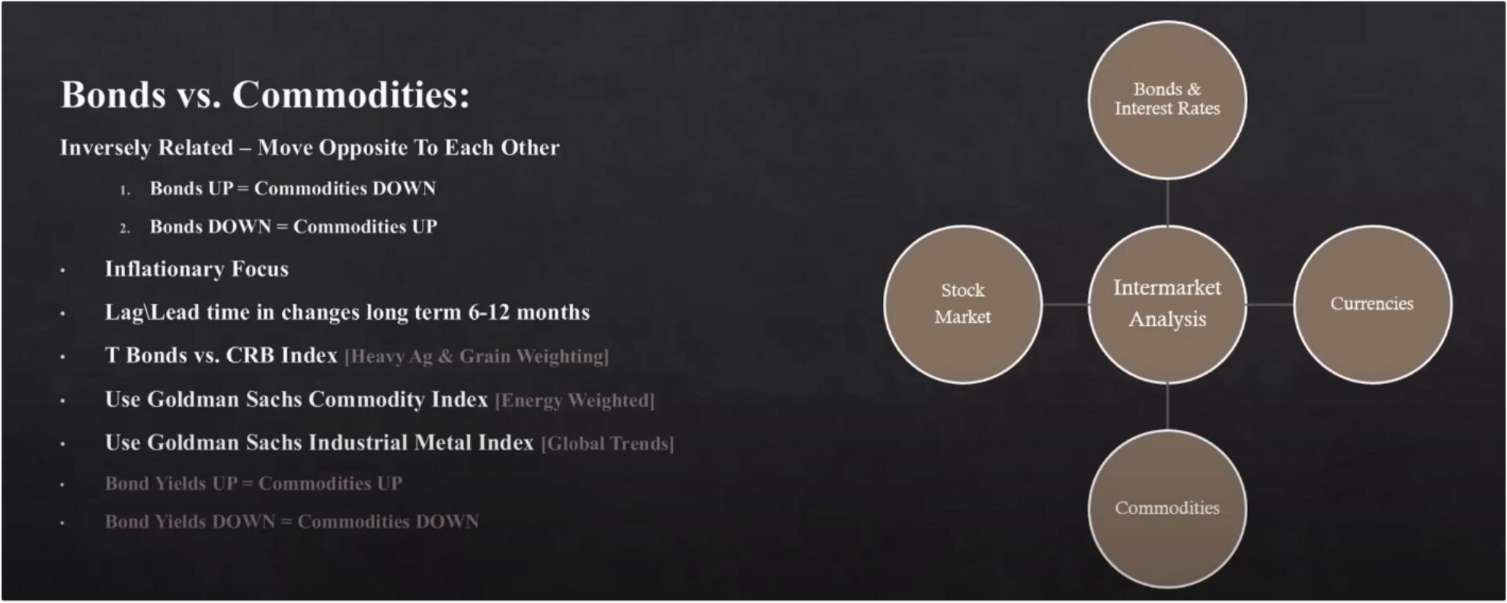

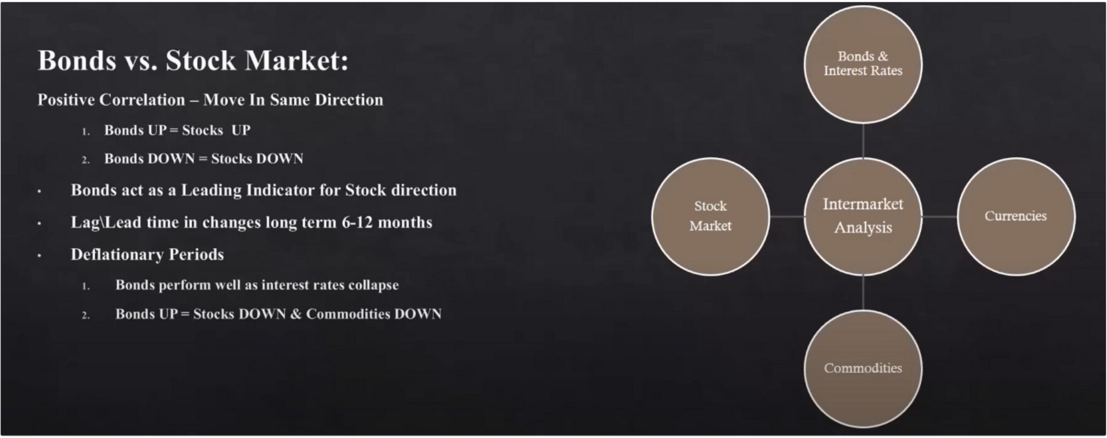

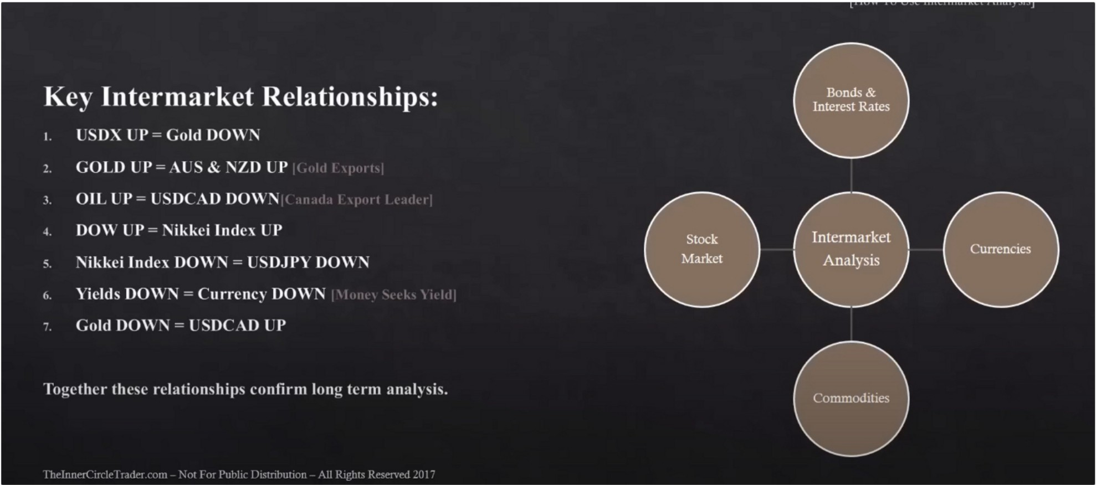

If youre seeing these things aligned with your technical analysis youre probably on the right path, youre looking at the right long term direction. The problem is timing, long term trends and timing is very hard. This will help you in all kinds of trading, daytrading to scalping and swing trading, everything.

This will give you confidence that the long term is backing your trades, and it will spare you the headaches of going trough all the data every month

This will give you the same outcome as looking at the fundamental data. Just like the fundamental data it can lag. Just becaause the data is released doesnt mean it will immediately do that, it can take some time

Arjo I Twitter, lnstagram I Linktree

Linktree. Make your link do more. https://t.co/HhmmTN1fUI

JavaScript is not available.

"I# https://twitter.com/arjoio